# Assignment 3

## ImageVis3D Hand Visualizations

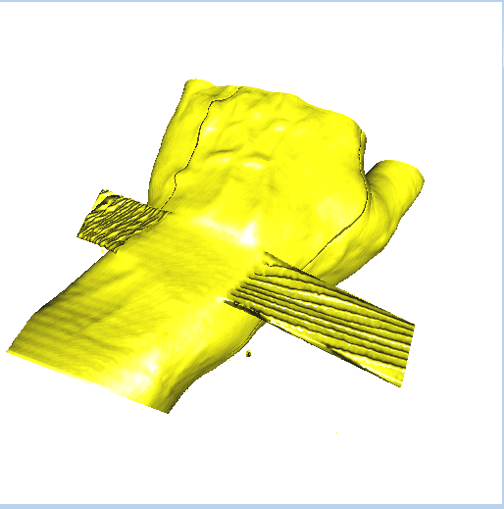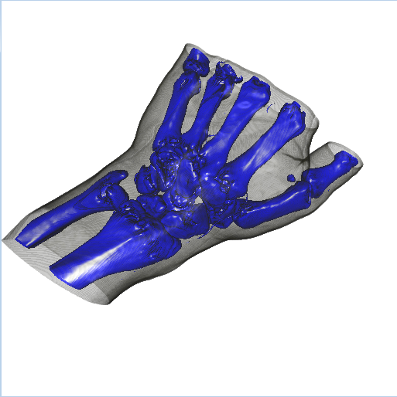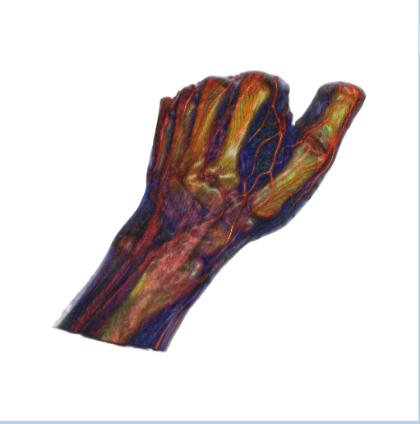

Figure – Hand Renders in ImageVis3D

For the yellow image, I used an Isosurface filter with the slider set to about 75 and enabled a yellow color map. For the blue image I used a 1D transfer function with the skin RGBA values set to about 10% of the max and the bone values I set Blue and Alpha to 100%, I let everything else be zero. For the third image I used a 1D transfer function to set the bones yellow with a smooth RGA curve and then increased the red filter to spike at the blood vessels, blue values are pretty much zero with a boost for the subsurface flesh.

Isosurface Values

* Skin: 60 – 800
* Blood Vessels: 1000 – 1100
* Bone: 1150+

## Paraview Hand Visualizations

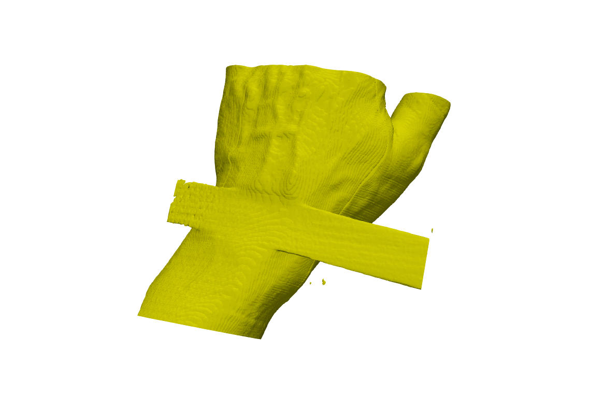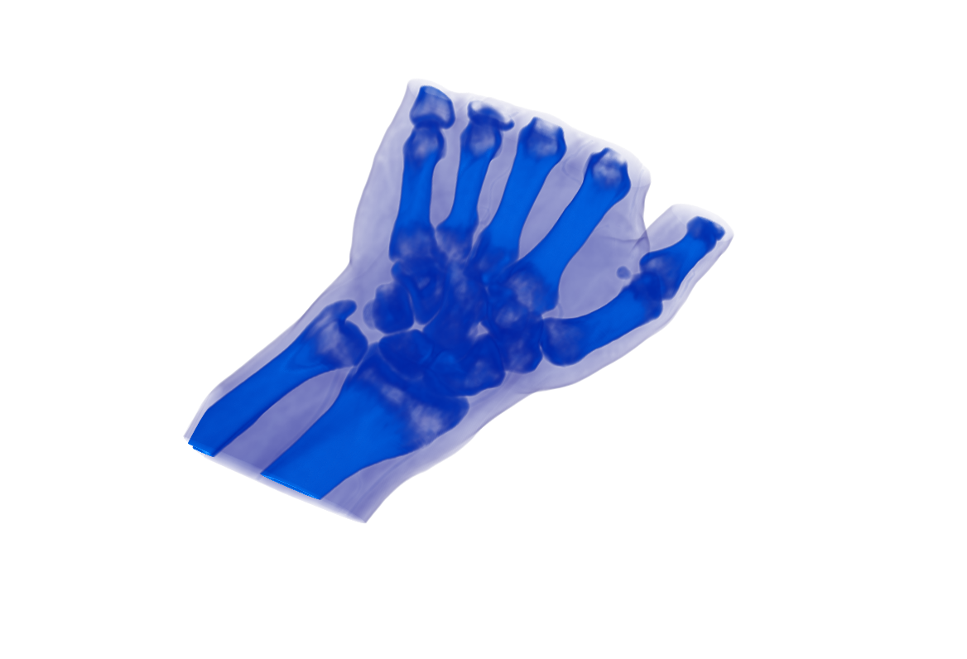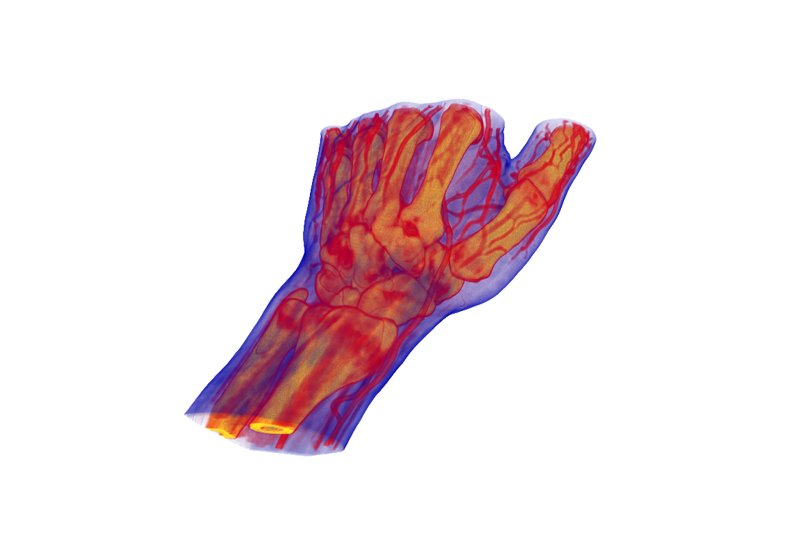

Figure - Hand renders from Paraview.

For the yellow image, I applied an Iso Volume filter and set the sliders to about 75, and messed with the color map to get a reasonable yellow color. The surface is a bit less smooth than the ImageVis3D, but I think if I continued to adjust options I could change that. The blue image was generated from using a cooler colored color map and boosting alphas at the correct regions. The third image, I applied a hot/cold color map and spiked the intensity at the appropriate regions. I found ParaView far less intuitive for this task.

## ImageVis3D Present Visualizations

Objects found using the 1D transfer function with a smooth curve through the range or isometric surface and just scanning through the values. I didn’t particularly find the 2D transfer functions to be terribly helpful.

1. Outerbox wrapped in string with starred wrapping paper
2. Inner crate
3. Bulbous thing – possibly a crystal ball? It is made of two pieces
4. Mouse
5. Toy #2 – possibly an otter or a lizard?
6. Strange Fasteners or buttons?

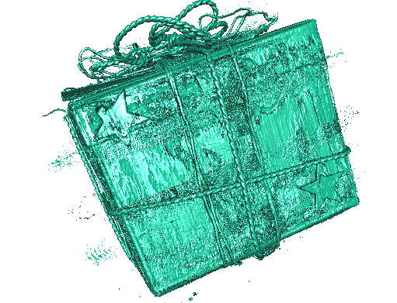 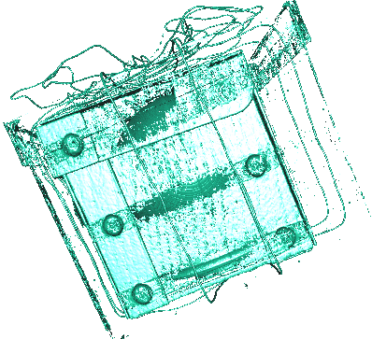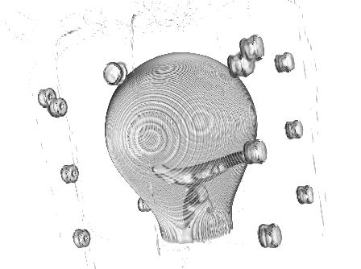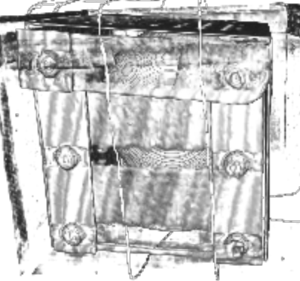

Figure - Various Objects found in the Present.

## Paraview Present Visualizations

I used a colormap and just boosted intensity in various regions to identify the objects in the present.

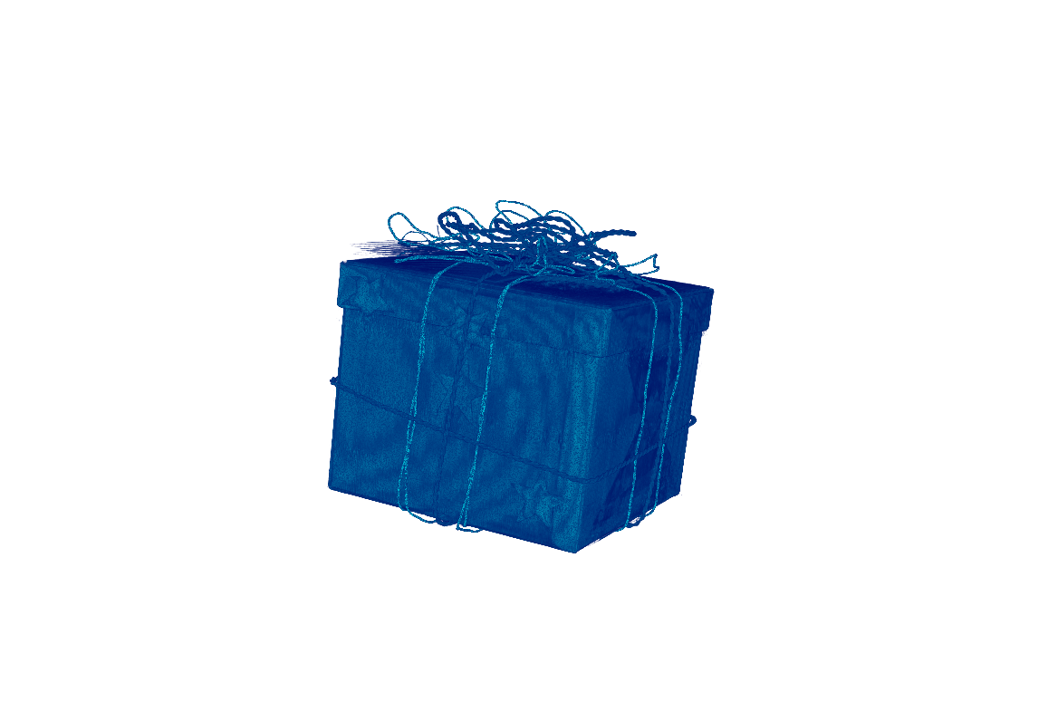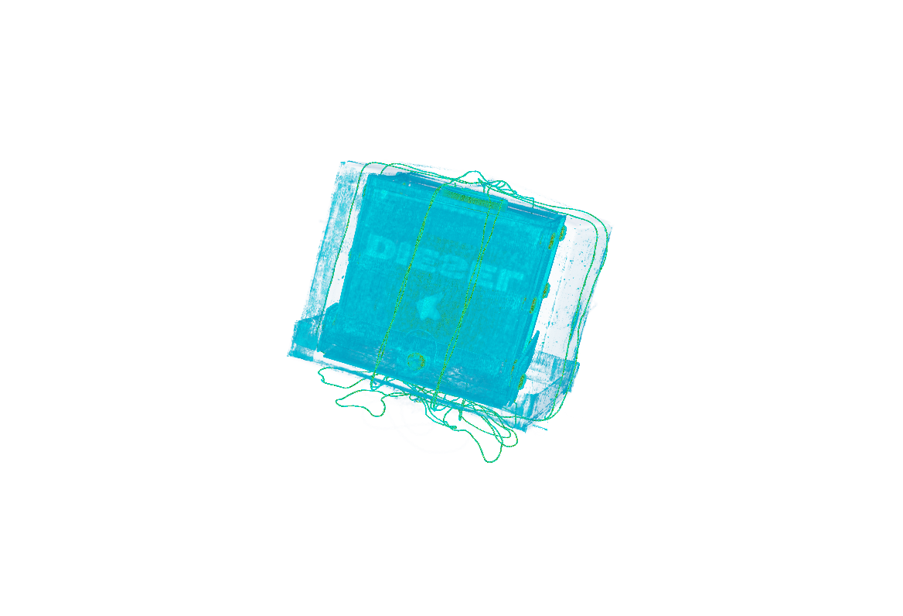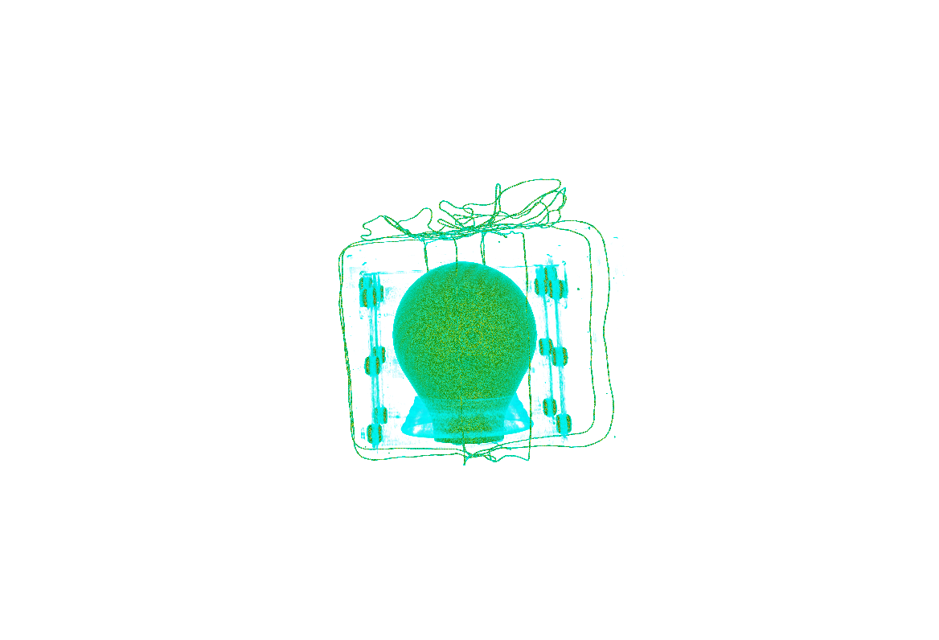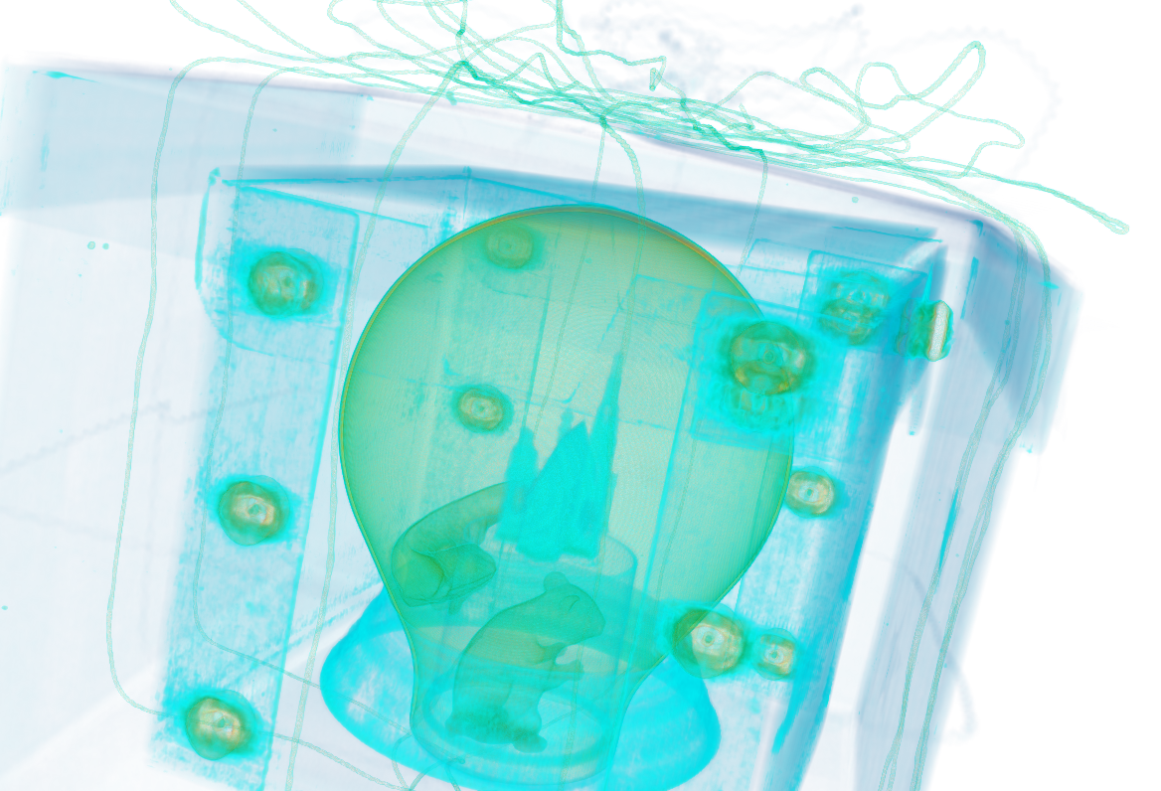

Figure - Present objects present in ParaView.

1. Again outerbox wrapped in paper with string and stars.
2. Inner crate box (this time you can see the DIESEL branding)
3. Bulbous thing, potentially a crystal ball?
4. Mouse
5. Toy #2 (otter or lizard)
6. Strange fasteners
7. There appears to be a small castle or house on top of a cylinder covering the mouse.

I ended up finding one additional object when I used Paraview for this task, and I got a bit more information about the box (DIESEL branding). I don’t know that Paraview was easier to use, but I was able to get more information with it. Perhaps as I build more familiarity with the tool, it will become easier.

## Visualizations of Multiresolution data:

This may seem obvious, but the higher resolution image is much bigger (file size and render size) in ParaView. The finer details like the appendages near the horns (antennae?) are much clearer in the higher resolution version, even when zoomed in appropriately for both images. As for performance, it took my python script about one to two orders of magnitude longer to convert from .dat to .raw. This is to be expected as the file size is about 60 times greater.

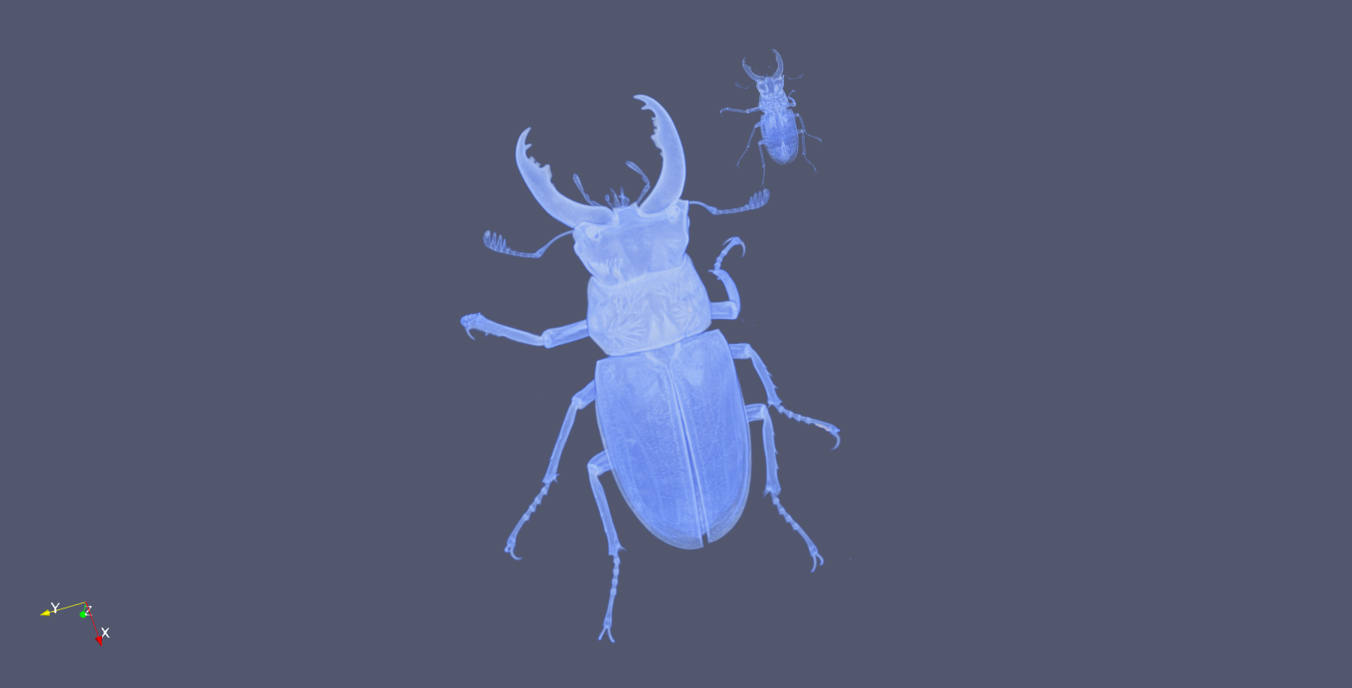

Figure - Beetle renders compared.

## Grad Student Section

I am not enrolled in the graduate section of this course.